Resume
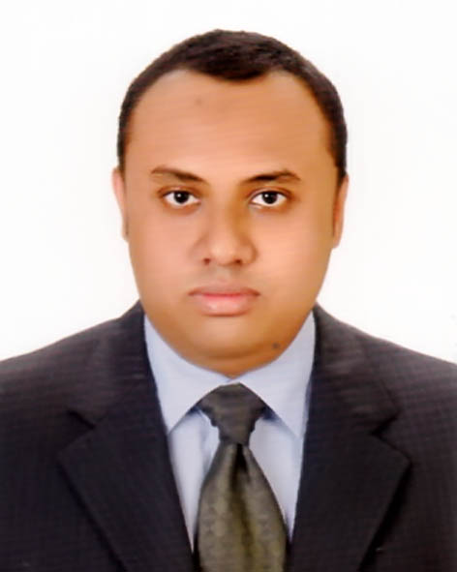

Akifur Rahman
691 Bara Mogh Bazar, Dhaka-1217.
Mobile: +8801684570259
E-mail: akifboss@gmail.com
Objectives:
To pursue a professional career in an organization that provides an excellent job environment for career growth and practices a professional performance culture where quality performance of talent and creativity is recognized and rewarded.

Educational Qualification:
MBA (2017)
Major In Accounting
CGPA -2.94 (out of 4.00)
Eastern University
Dhanmondi, Dhaka.

BBA (2015)
Major In Accounting
CGPA-2.88 (out of 4.00)
Eastern University
Dhanmondi, Dhaka.

HSC in Business Studies (2009)
GPA-4.40 (out of 5.00)
Dhaka Imperial College,
Mirpur Road, Dhaka.

SSC in Science (2007)
GPA-3.56 (out of 5.00)
Wills Little Flower School & College,
Kakrail, Dhaka-1000.

Computer Skills:
- Proficiency in operating Microsoft Office.
- Efficiency in Internet browsing, Adobe Photoshop, Adobe Illustrator, Adobe Reader

Language Competencies:
- Excellency in four way communication skills both in English and Bengali.
- Received Certificates for course completion on Practical Spoken & General English from “Saifurs”.

Working Experience:

- Three Months experience of Internship on “Exim Bank Limited”, new Eskaton Branch, Dhaka from 24/05/2015 to 23/08/2015.
Extra-Curriculum Involvement:
- Organized and participated in various seminars and cultural activities at the school and college period.
- Participated in Science Fair in the school period.
- I have got 100% Attendance Award for regular class in Dhaka Imperial College, Dhaka
Strengths:
- Hard working
- Participative in group tasks
- Ability to grasp subject matter quickly
- Structures way of working
- Good analytical skills

Interests and Hobby:
- Reading and collecting books
- Collecting Stickers
- Using Computer

Personal informations:
Name : Akifur Rahman
Father’s Name : Zillur Rahman
Mother’s Name : Hashmat Jahan
Present Address : 691 Bara Mogh Bazar, Dhaka- 1217
Permanent Address : Jagannathpur, Bhairab, Kishorgonj
Date of Birth : 2nd December, 1992.
Religion : Islam
Marital Status : Unmarried.
Gender : Male.
Nationality : Bangladeshi.

Reference:

- Dr.Md.Ziaur Rahman
Physician & Surgeon
On Deputation

Dhaka Medical College Hospital

___________________
Signature

